**ASSIGNMENT 4:**

**Module 5: Files, Exceptions, and Errors in Python**

**Task 1: Read a File and Handle Errors**

**Problem Statement:** Write a Python program that:

1. Opens and reads a text file named sample.txt.

2. Prints its content line by line.

3. Handles errors gracefully if the file does not exist.

**Expected Output:**If the file exists:  
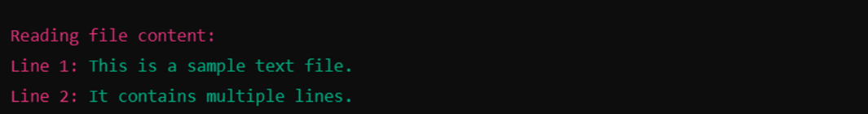If the file does not exist:



**Task 2: Write and Append Data to a File**

**Problem Statement:** Write a Python program that:

1. Takes user input and writes it to a file named **output.txt**.

2. Appends additional data to the same file.

3. Reads and displays the final content of the file.

**Expected Output:** For example, if the user enters 25, the output should be:  
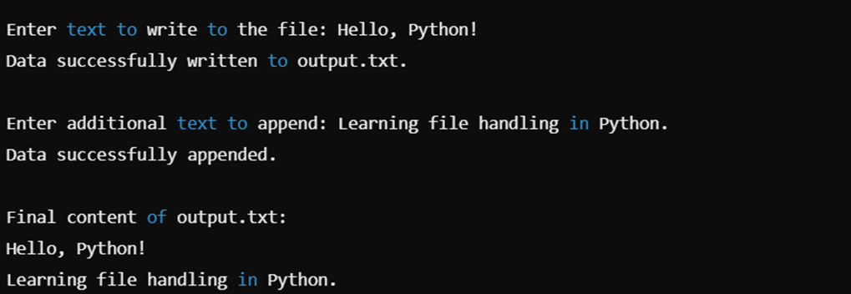

**Submission Instructions:**

* Create a **GitHub repository** and upload your Python scripts (.py files).
* Ensure the repository includes a **README.md** file that describes the functionality of your programs.
* Add both **Task 1 and Task 2** scripts in the same repository.
* Submit the **link to your GitHub repository** once uploaded.

**Reference:**

Follow the **Python course - Module 4: Functions & Modules in Python** for additional guidelines and examples.

**Note:**

**Please test your project thoroughly and check all the validations and error handling prior to ensure it works as expected before submission.**

**You can always connect to the mentor using the chat support option for any doubts or queries!**